JUNIOR AUXILIARY OF ABBEVILLE PRESENTS
DIAMOND FEVER SOFTBALL TOURNAMENT
April 15 & 16, 2023
NVYAA
4 Game Guarantee
$20 per player*
Format: 7 men and 3 women
Registration Deadline: April 7th
Pool play begins Saturday morning

$30 Ice Chest Fee $3 Entry Fee
(per day) Under 5 Free
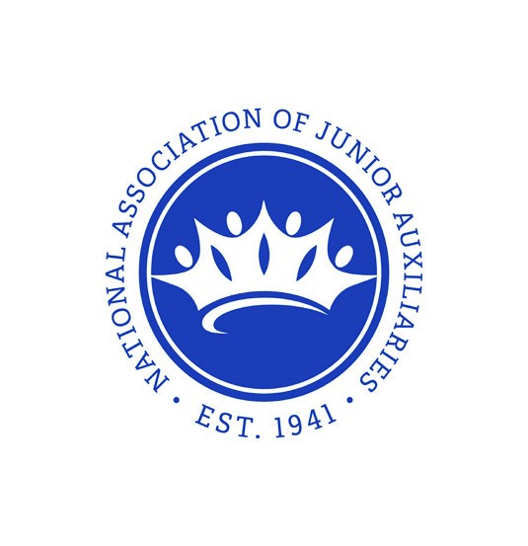
Sponsorship Levels:
$500 Diamond Sponsor
$250 Pearl Sponsor
$100 Friends of JA
PROCEEDS BENEFIT
JA of Abbeville Service Projects
Concession will be sold by NVYAA
Contact Information:
Kaye Choate- 337-706-4189
Player Payment Information:
- Team manager can write one team check and mail it in.
- Players can pay when entering gate prior to first game played (must be on roster turned in).

JUNIOR AUXILIARY OF ABBEVILLE CO-ED SOFTBALL TOURNAMENT
Sponsorship Form
Thank you for your interest in being a sponsor of JA of Abbeville softball tournament. Without donations from our community members and businesses, this tournament would not be possible. Because of the generosity of our patrons, we are able to give back to help the children of Vermilion Parish.
The event is scheduled for April 15 & 16 at North Vermilion Youth Athletic Association.
By completing the form below, you are stating that you have read the sponsorship tiers and agree to sponsor JA of Abbeville softball event.
The deadline for sponsorship submissions is: April 7, 2023.
Please complete this form and return with payment to: JA of Abbeville, PO Box 1404, Abbeville, LA 70510. Checks can be made payable to: JA of Abbeville. E-mail logo to kaye.choate@yahoo.com.
Point of contact ___________________________________ Phone (______)_______________________________________
Business Name ____________________________________ E-mail ____________________________________________
Business Address ______________________________________________________________________________________
Sponsorship Level _________________________________ Amount of Donation ___________________________________
Signature _____________________________________________________________________________________________
Diamond Sponsor $500 | Field Sponsor: Company logo on banner in the outfield Facebook & event recognition
Pearl Sponsor $250 | Dugout Sponsor: Company logo on banner on team dugouts Facebook & event recognition
Friends of JA $100 | Facebook & event recognition

TEAM ENTRY INFORMATION
Acknowledgement and Acceptance of Tournament Rules
Team Name:___________________________________________________
Manager/Alternate:_____________________________________________________
Address:_______________________________________________________________
Cell Phone:________________ E-mail:_____________________________________ By my signature hereunder, I acknowledge and accept the following:
- I am the Team Representative, Manager, or Captain of the undersigned team.
- I have received and reviewed a copy of the Tournament Rules governing the JA of Abbeville Softball Tournament and Requirements for my Co-Ed team.
- Each player on the submitted roster for the undersigned team received, will receive, or will be otherwise informed of the Tournament Rules and Regulations and be specifically advised that unsportsmanlike conduct will not be tolerated.
- Before playing each player will acknowledge having been advised of these rules by signing the team entry form next to their name on the list.
- Any team or individual player not abiding by the Tournament Rules will be subjected to disqualification from the tournament and/or ejection from the game in the sole judgment of the Tournament Directors.
- No refunds will be provided to any team or individual player that is ejected or disqualified from the tournament.
Date Signed:______________________________________
Signature:________________________________________
Printed Name:____________________________________
Team Name:______________________________________
JA of Abbeville
SOFTBALL TOURNAMENT
Rules and Regulations
- Umpire/Tournament decisions are final.
- Walking a male- if a male is walked and the following batter is a female, the female batter may take awalk.
- Home Runs- For every home run, there will be a $5 charge. A player can purchase a $50 bracelet forunlimited home runs for the weekend.
- Run rules will apply. The game will be over if a team is up by 15 runs after 3 innings, or 10 runs after 5 innings.
- Teams will be Co-Ed. There must be a minimum of 10 players, 3 of which are female.
- The Halo Rule will apply-- if a line drive hits the pitcher, the batter is automatically out.
- Players are only allowed to play on one team. They cannot switch teams for tournament play.
- Teams are required to have a minimum of 3 females playing the field at all times.
- Every hitter starts with a 1-1 count (1 ball, 1 strike) and they have a courtesy foul. A courtesy foulmeans that the player starts with a 1 and 1 count; if he fouls off a ball, the player has two strikes the hitter will have a courtesy foul. Game speed-up rules if necessary-will be a 1 pitch per at bat-will apply to Sunday only.
10.Games will run 50 minutes. The inning in progress will be finished.
11.The order of batting remains the same for each inning. The batting order continues where it left off at the end of the last inning. The normal Co-Ed for 7/3 format will have the girls batting in the 3,6,&9 spot. If the team is batting 12, the female will be in the 12th spot. For 6/4 format, the girls will bat in the 1,4,6, and 9 spot. For the 5/5 format, males and females will alternate. If there are only 2 females available, the team will be able to play with 9, and the 10th spot will be an automatic out.
12.Players are playing at their own risk; JA of Abbeville is not responsible for injuries or accidents that occur during the tournament.
13.Incrediball will be used in tournament play and will be provided by the Tournament sponsors on the day of the event. They must be returned at the end of tournament play.
14.Foul or vulgar language will not be tolerated in the stands or fields of play. It is the intent of JA of Abbeville to maintain a family type of atmosphere for all to enjoy. Loud obscene language is ground for removal from the tournament and park.
15.No specific reason is required to disqualify a team that in any way circumvents the intent of the tournament directors and/or the tournament rules. We expect each team to support the tournament and the intent of the rules.
16.With team and player cooperation, we do not expect to have issues with the rosters and sportsmanship.

JA of Abbeville
SOFTBALL TOURNAMENT Roster Form
Team Name ________________________________ Captain's Phone(______) _________________________________
Captain's Name ______________________________ Captain's E-mail_______________________________________

Members Print and Sign
1.________________________________________________________________ 2.________________________________________________________________ 3.________________________________________________________________ 4.________________________________________________________________ 5.________________________________________________________________ 6.________________________________________________________________
7.________________________________________________________________
^{8.}________________________________________________________________
9.
10.________________________________________________________________
________________________________________________________________ 11.
________________________________________________________________ 12.
________________________________________________________________ 13.
________________________________________________________________ 14.
________________________________________________________________ 15.
________________________________________________________________ 16.
________________________________________________________________
^{17.}________________________________________________________________ ^{18.}________________________________________________________________
^{19.}________________________________________________________________
^{20.}________________________________________________________________ Waiver of all events
We understand that by signing this waiver we are agreeing to hold harmless JA of Abbeville and all volunteers involved in the
Softball Tournament. I waive and release JA of Abbeville, the Tournament Committee, volunteers, and their representatives and successors from all claims or liabilities of any kind arising out of participation in this event. We understand that softball is a physical sport and injuries might occur.

